###### OVERVIEW

* 1. **Business Goals**

Online shopping System would give a client business to use advanced yet simple, scalable and technologically feasible computerized system with goals of reduce processing time, streamlining of secured data exchanges between customers and suppliers.

* 1. **Business Process Overview**

A user would be registered and approved by the administrator of the system. The shopper then lands into the Products List page where they can browse catalogs, view individual products and add them to the shopping cart. After the shopper adds everything to the cart, they can checkout using their details and payment method. Once the shopper places the order, the order gets sent over to the Vendor who can approve or reject the order. After Vendor approves the order, the user is sent a confirmation email with the details of the delivery.

The key processes of the system are:

* + 1. Order Management
    2. Product Management
    3. Category Management
    4. Payment Settlement
    5. User Management
    6. Report generation
    7. Shopping cart Management

**Business Process Overview Diagram**

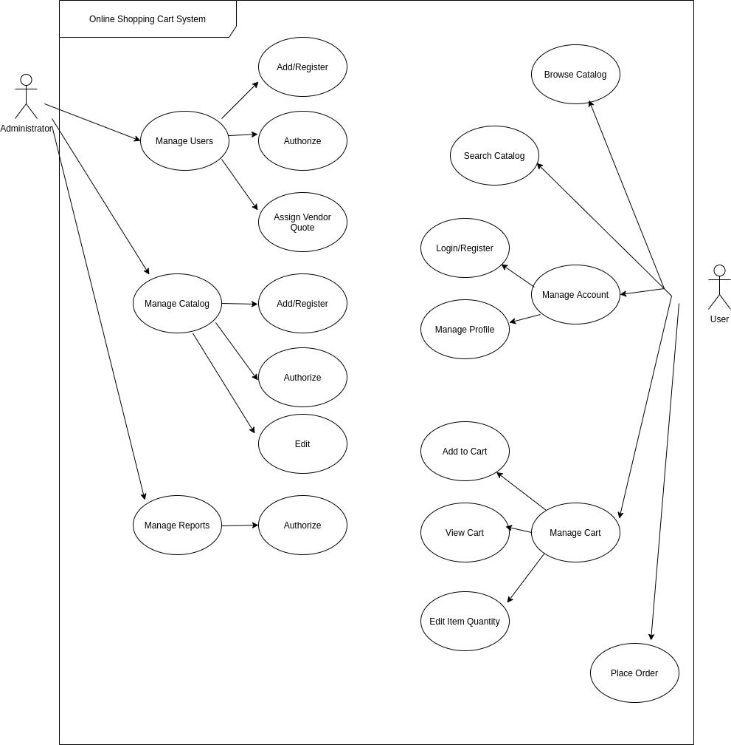

* 1. **Objectives of System**

The key objectives of the business processes identified above for the system are:

* + 1. Order Management Process

To enable the user to add products to the cart and place an order and let the vendor approve the order and process the delivery.

* + 1. Product Management Process

To enable vendors to add products and categories to the system and the admins will be approving or rejecting the products.

* + 1. Category Management Process

To manage and display the products according to the category.

* + 1. Payment Settlement Process

After placing the order, the payment management process will verify the payment details such as card number, billing address and confirm the order. Once the verification is complete, the user will be sent an invoice via email.

* + 1. User Management Process

To register and login the system users and provide the access according to the roles. Validate the authorization to access the services

* + 1. Report generation Process

To generate the PDF/HTML formatted report which contains a list of products purchased with their prices and their total price of the sales based on the product and the price of the product which only the manager and the vendor can access.

1. **BUSINESS PROCESS** 
   1. **Process map**
      1. **Order Management Process Map**

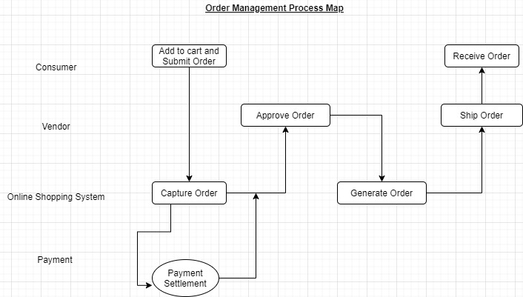

* + 1. **User Management Process Map**

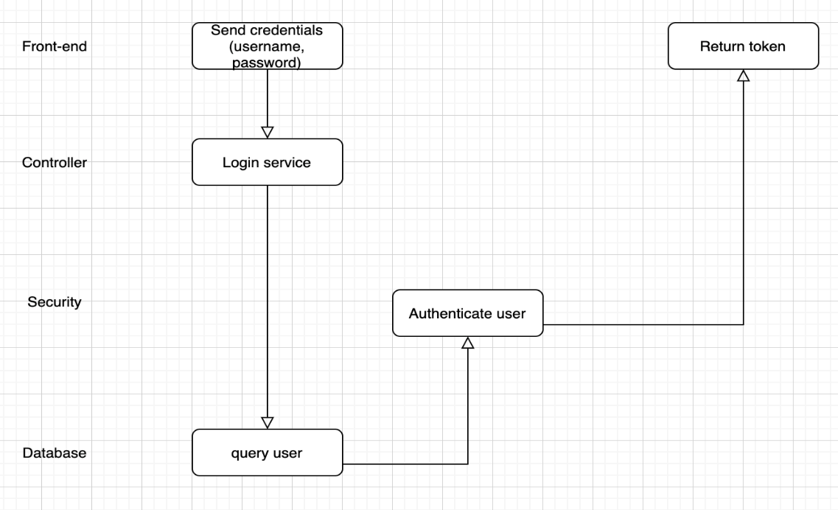

* + 1. **Payment Settlement Process Map**

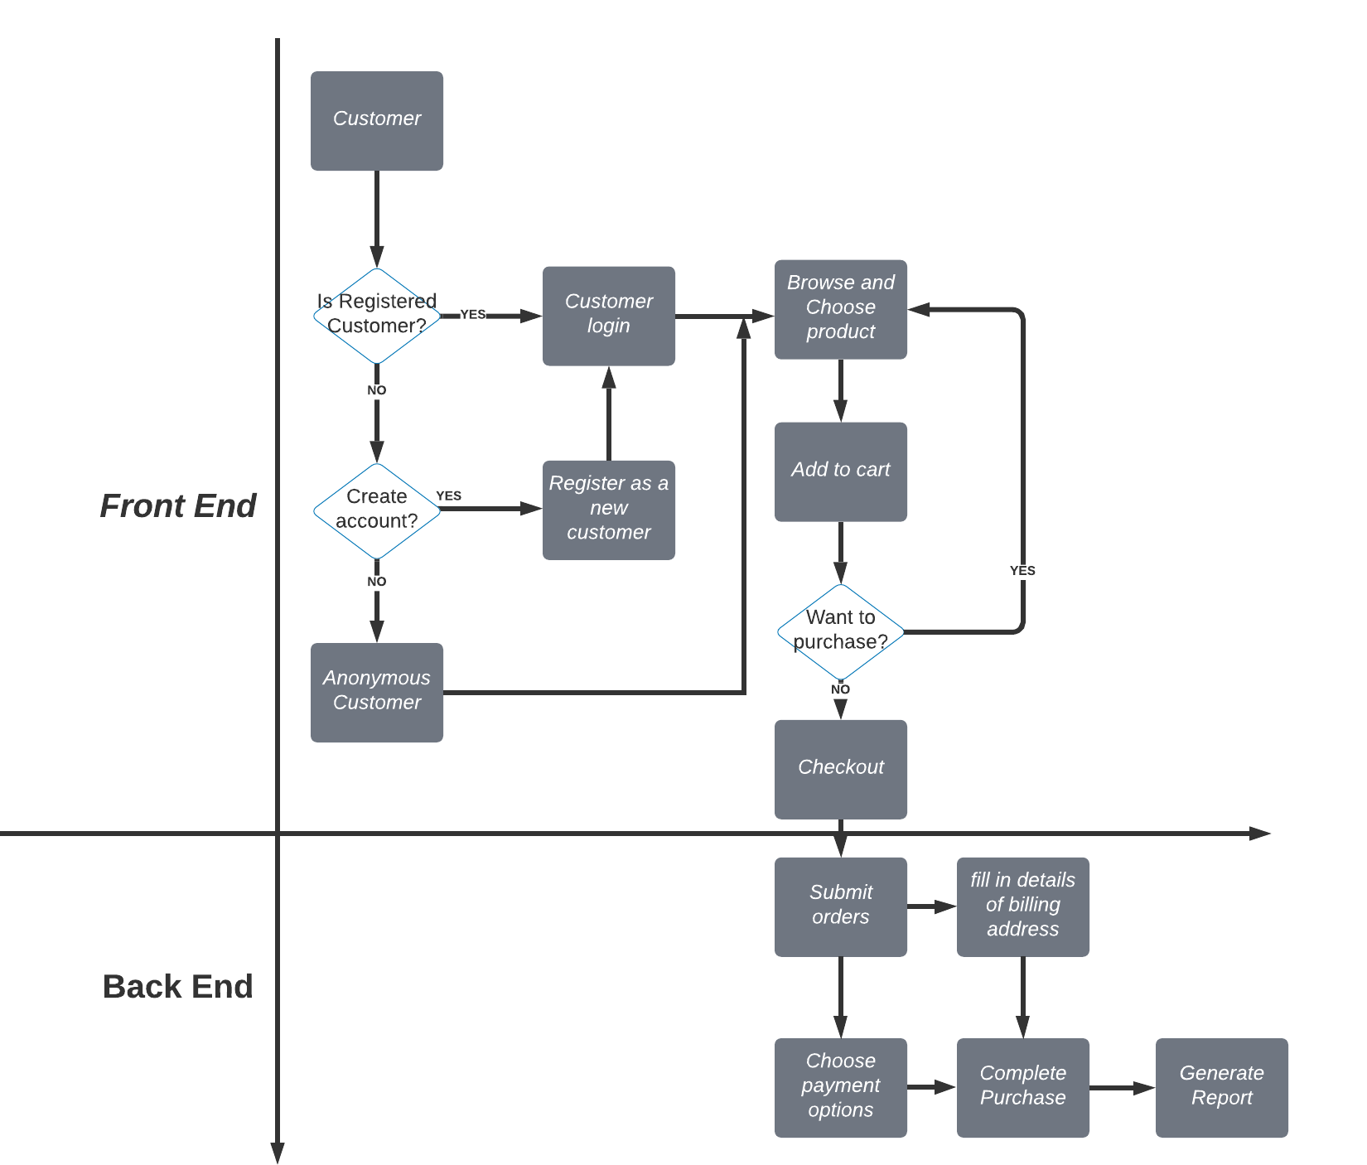

* + 1. **Report Generation Process Map**

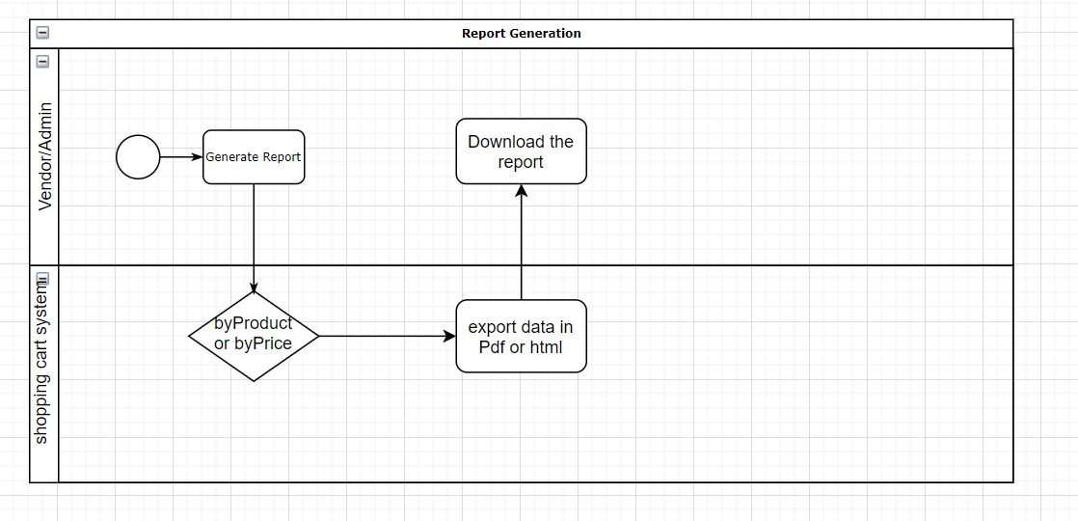

* + 1. **Category Management Process Map**

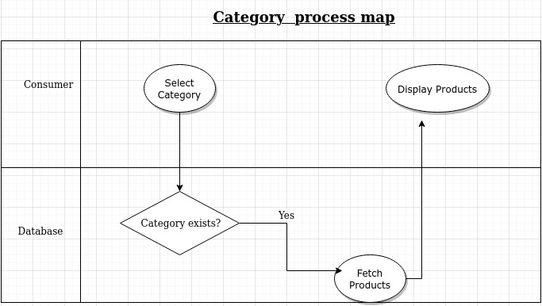

* + 1. **Product Management Process Map**

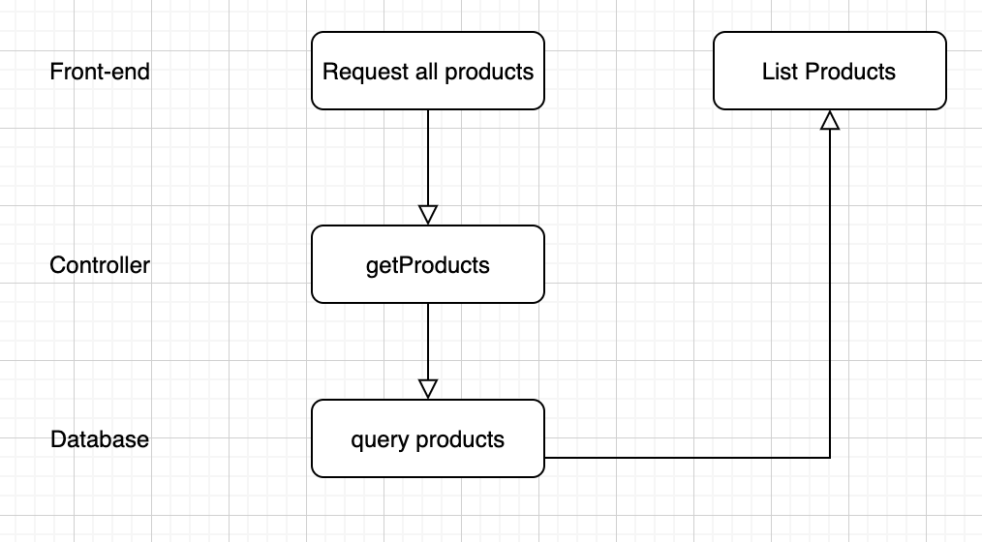

* 1. **Business Functions**

List the business functions (sub-process) to be computerized.

2.2.1. Register User

2.2.2. Login User

2.2.3. Generate Report

2.2.4. Place an order

2.2.5. Approve Products

2.2.6. Display Products

2.2.7. Approve Payment

1. BUSINESS FUNCTIONS
   1. **Functional Overview**

Overview of business functions using Functional Hierarchy is shown below:

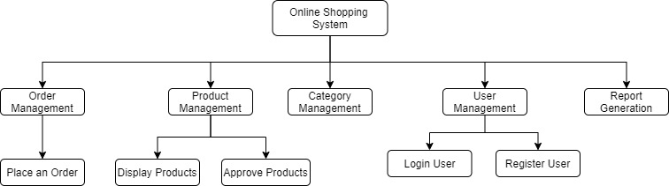

* 1. **Functional Requirements** 
     1. **Register User**

Description of the Function

A user Management module would be available for users to register themselves into the system.

Role

Any User

Input

User Details

Output

A registered User

Flow of Events

The following picture shows the flow of the user registration process

* + - 1. **Event Table**

|  |  |  |
| --- | --- | --- |
| Sequence No. | Role’s Action | System Response |
| 1 | Add User details | Generate a Record |
| 2 | Assign a role for the User | Role Assigned and Record saved in Database |

* + - 1. **Sequence Diagram**

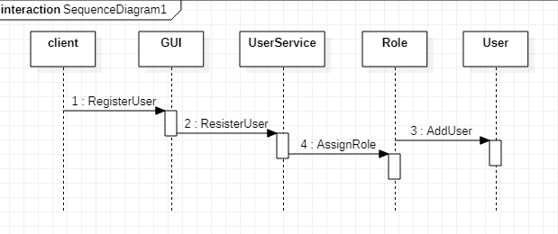

* + - 1. **Business Processing Rules**
         1. User should have a role
         2. Tax will follow the shipping address.
         3. Shipping address and Billing address can be different.
         4. User should have valid Address to be approved
    1. **Login User**

Description of the function

User can login in the application with the credentials, username and password. The system will validate and authenticate the user returning a Json Web Token.

Roles

Vendor, Admin (Management), user

Input

Username, password

Output

PDF or HTML format of the product report

Flow of Events

The following shows possible ways of capturing the flow of events:

* + - 1. **Event Table**

|  |  |  |
| --- | --- | --- |
| Sequence No. | Role’s Action | System Response |
| 1 | Click Login | System Request User Details for Authentication |
| 2 | User Provides Login Details and click Login | System Opens or Provide Error Message |

* + - 1. **Sequence Diagram**

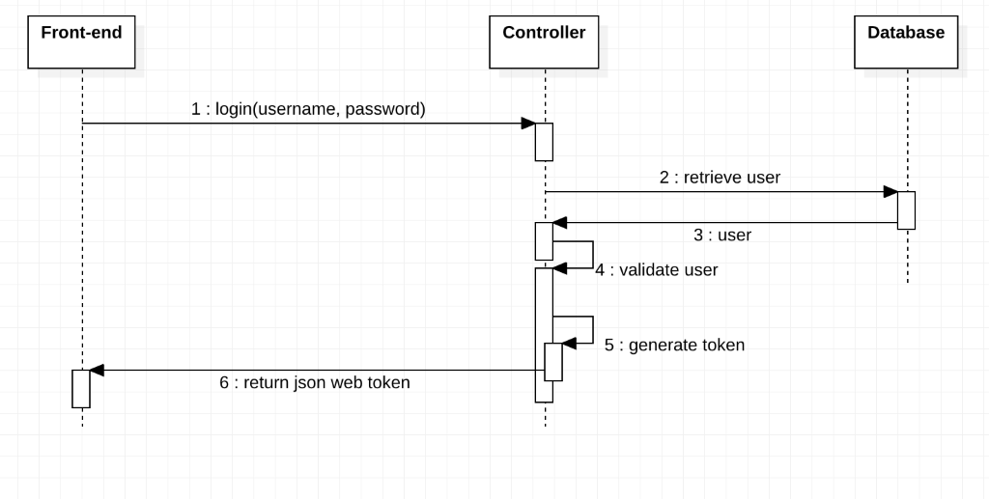

* + - 1. **Business Processing Rules**
         1. After three consecutive failed login the user is locked out
         2. User will be given an option to save username and password
         3. Shipping address and Billing address can be different.
         4. Check number of stocking item before confirming the order
    1. **Generate Report**

Description of the function

A reports generation module must be available for management and vendors to see the status of the sales online in terms of products and in terms of Dollar value.

Roles

Vendor, Admin (Management)

Input

Sale or product details

Output

PDF or HTML format of the product report

Flow of Events

The following shows possible ways of capturing the flow of events:

* + - 1. **Event Table**

|  |  |  |
| --- | --- | --- |
| Sequence No. | Role’s Action | System Response |
| 1 | Click get Report | Generate report of the product in PDF/HTML format |

* + - 1. **Sequence Diagram**

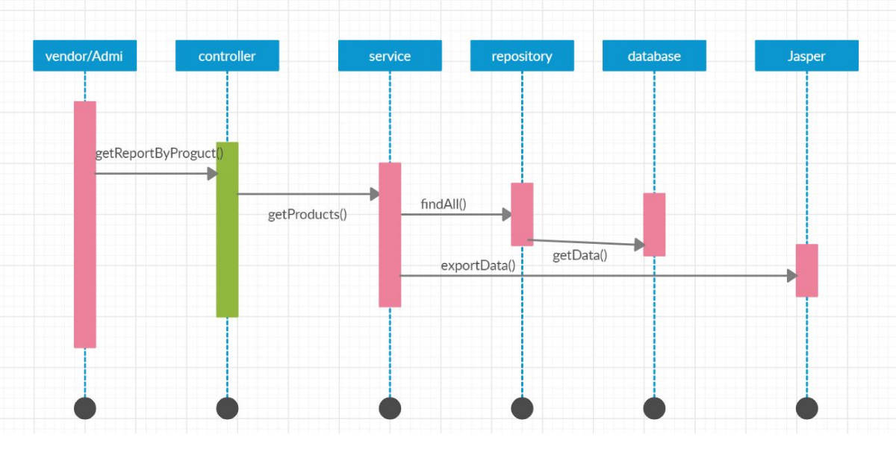

* + - 1. **Business Processing Rules**
         1. Report access is based on the role of the user
    1. **Approve Product**

Description of the Function

Vendor requests approval for the product from Administrator

Role

Vendor

Input

Product Details

Output

Approved Product

Flow of event

The following diagram shows the flow of events

* + - 1. **Event Table**

|  |  |  |
| --- | --- | --- |
| Sequence No. | Role’s Action | System Response |
| 1 | Input product into the system | Validated Product details |
| 2 | Request approval for the product | Approval Request for the product |
| 3 | Approve Product detail | Approved Product detail |
|  |  |  |

* + - 1. **Sequence Diagram**

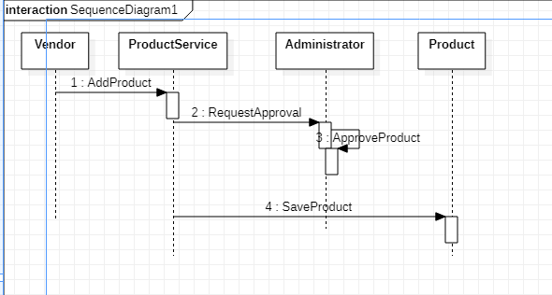

* + - 1. **Business Processing Rules**
         1. Product should not be already registered in the system
    1. **Approve Payment**

Description of the function

The Customer submit payment, the system submits card transaction request to the customer's card bank. Bank could approve or reject the transaction. If transaction is approved, payment completed.

Roles

Customer, Shopping cart, Customer’s Bank system

Input

Submit payment

Output

Payment succeeded or rejected

Flow of Events

* + - 1. **Event Table**

|  |  |  |
| --- | --- | --- |
| Sequence No. | Role’s Action | System Response |
| 1 | Submit payment | Sends card information to the customer’s bank |
| 2 |  | Approved/Rejected Transaction |

* + - 1. **Sequence Diagram**

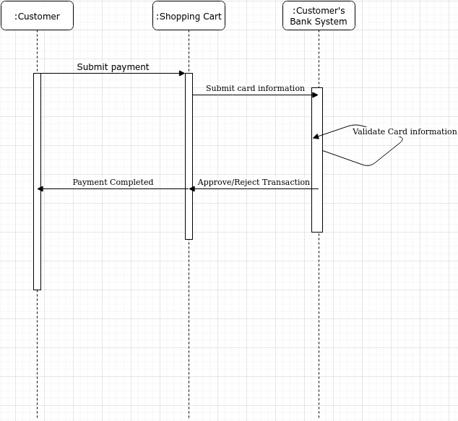

* + 1. **Display products**

Description of the function

User request the list of products per vendor

Roles

User

Input

Vendor identification

Output

List of products

Flow of Events

The following shows possible ways of capturing the flow of events:

* + - 1. **Event Table**

|  |  |  |
| --- | --- | --- |
| Sequence No. | Role’s Action | System Response |
| 1 |  | Generate list of the product |

* + - 1. **Sequence Diagram**



* + - 1. **Business Processing Rules** 
         1. Check number of stocking item before confirming the order
    1. **Place an Order**

Description of the function

User can add product into shopping cart, edit the quantity of products, fill out information for order

Roles

User

Input

Shopping cart’s items, user’s information

Output

An order waiting for approve

Flow of Events

The following shows possible ways of capturing the flow of events:

* + - 1. **Event Table**

|  |  |  |
| --- | --- | --- |
| Sequence No. | Role’s Action | System Response |
| 1 | Add product | Add product into User’s shopping cart, save shopping cart into database |
| 2 | Edit quantity | Edit quantity of product in User’s shopping cart, can remove order if set quantity to 0 or click Remove.  Can clear all the items on shopping cart |
| 3 | Place an order | Collect user’s information for payment and checkout |

* + - 1. **Sequence Diagram**

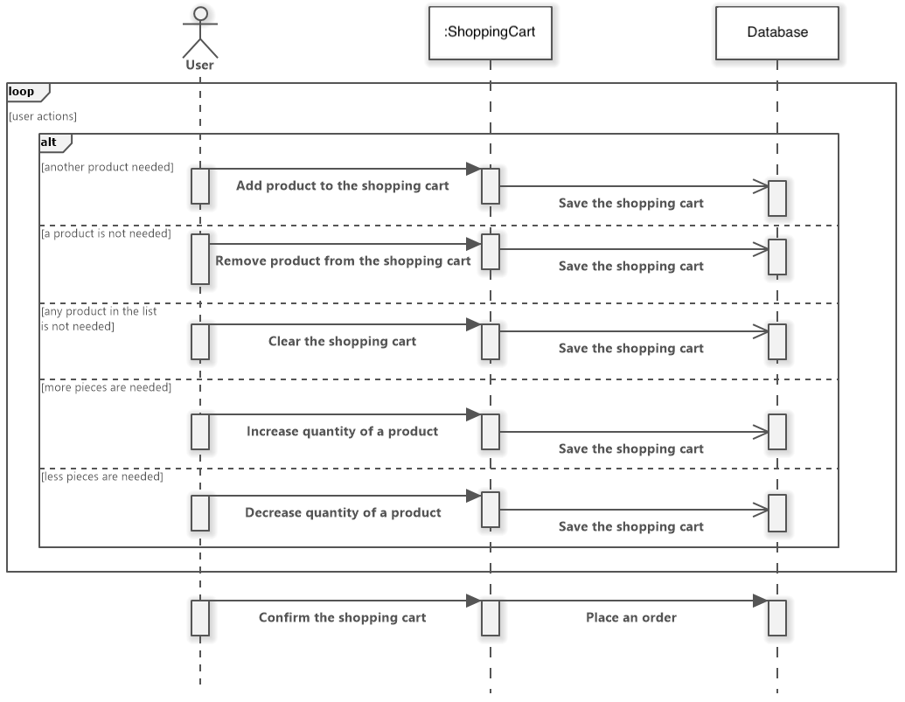

* + - 1. **Business Processing Rules**
         1. Total cost = [å (quantity * price)] * tax
         2. Tax will follow the shipping address.
         3. Shipping address and Billing address can be different.
         4. Check number of stocking item before confirming the order

1. **OTHER REQUIREMENTS**

The typical requirements are documented as follows:

* 1. **SYSTEM PERFORMANCE** 
     1. System response maximum time is 10000ms
     2. System should available 24 hours a day, 7 days a week.
     3. Maintaining time should be notice to user before a week.
     4. System can be used by 500 clients at the same time.
  2. **SECURITY REQUIREMENTS**
     1. User’s password must be encrypted.
     2. User’s payment information must be encrypted.
     3. Only vendors or Administrators can edit information of products.
     4. Only trusted 3rd party can interact with API provided by system.

# SYSTEM/OPERATING ENVIRONMENT

* 1. **Communications Overview**

The front end and back end application will be communicating via the HTTP requests from the web server. The requests will be handled by web services in the back end and responses will be sent to front end in json format.

* 1. **Hardware Requirements/Configuration**

Any device with web browsers will be able to access the web application once it is deployed.

* 1. **Operating System**

Windows, Linux, MacOS, Android and iOS

1. **ASSUMPTIONS AND LIMITATIONS**  
   1. All team members have the required skills.
   2. The time constraint is enough for all the deliverables
   3. Users are registered and approved before using the system.
2. **USER INTERFACE DESIGN CONCEPTS**

The web pages will be built using react-bootstrap framework.

* 1. **Background**

Web page: White

Navigation bar: Black

* 1. **Screen layout (provide sample, if necessary)**

Cards

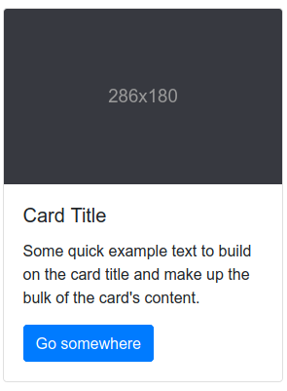

List-groups

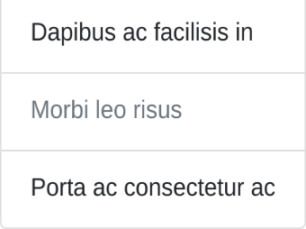

Tables

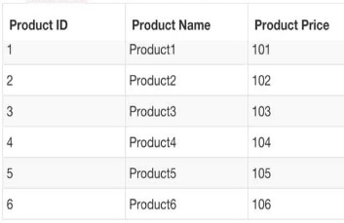

* 1. **User interactions**

The user will be interacting with the UI by clicking on Buttons, links, images, etc.

* 1. **Text font / style**

Default font and style of React Bootstrap

* 1. **Icons**

Icons will be leveraged from font-awesome library.

* + 1. User  
       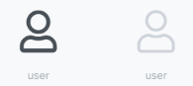
    2. Cart  
       
    3. Favicon  
       
    4. Homepage



* + 1. Sign-out   
       
  1. **Buttons**  
     Buttons will be leveraged using react-bootstrap library.
     + Sign Up
     + Login
     + Add to cart
     + Checkout
     + Place Order
     + Approve User/Product (Admin)
     + Reject User/Product (Admin)
     + Add (Vendor)
     + Remove (Vendor)
     + Approve Order (Vendor)

Examples:



* 1. **Navbar**

The navbar will be a permanent feature of the webapp which will be created using react-bootstrap.

Theme:



* 1. **Header / Footer / Terms and Conditions**

### Header, Footer, Terms and conditions will be using their default react bootstrap.

###### SCENARIO FLOW / USER INTERFACE DEMO

* 1. **Vendor Scenario**

Vendor registers themselves and logs in the system. They see a list of their own products on their homepage. Vendor can go to view all orders and approve or reject them. They can also manage their products by going to Manage Products page. They can add a new product, edit an existing product or remove the product.

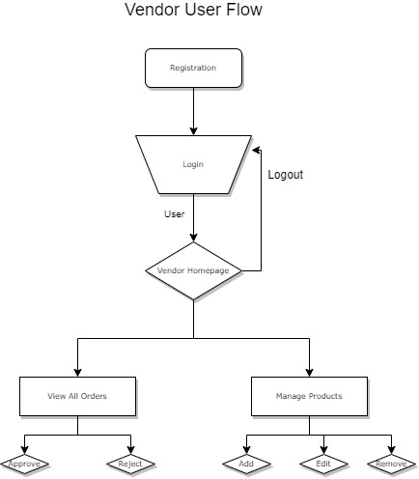

* 1. **Admin Scenario**

Admin can register themselves. After registration they can login and reach the admin homepage. From admin homepage the admin can go to manage Users page. There are two types of users that an admin can manage. Admin can manage shoppers and manage vendors. Admin will be able to approve new shoppers and vendors or reject them from the system. Admin can also view all the current orders in the system. Admins can also manage products by approving or removing new product request.

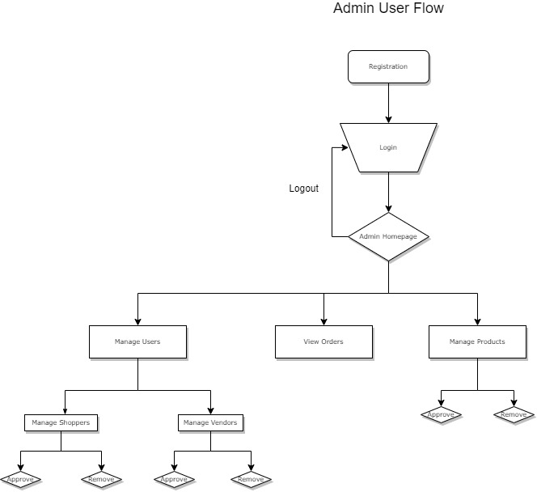

* 1. **Customer User Flow**

After logging in they will land on the User homepage which lists all the current products available. The user then can click on a product and go to the product page. They can modify the quantity they want and add the product to cart. User can also go to Cart page where they will see all the current cart items. Users can then modify the quantity from the cart itself and click checkout to go to checkout page. They will fill billing and shipping information and go to the payment details page where they will select the type of payment. After entering payment details the user will click place an order and an order will be sent to vendor for approval and user will be sent an email. Users can also go to user profile page and modify their own details. 

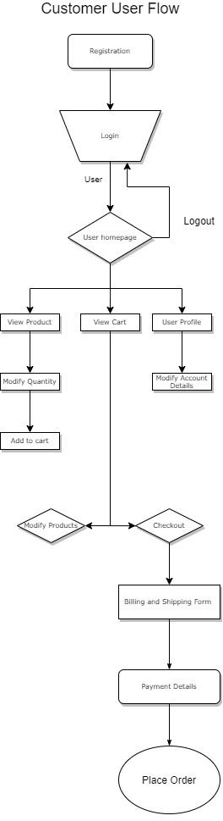

Project Lead: Anteneh Tessema

Client Lead: Amit Bhattarai

Team members: Jimmy, Ho, Christian, Xuan, Haftu, Meron, Daniel, Amit, Anteneh